Visual Studio 2019 – Community Edition Download

<https://visualstudio.microsoft.com/downloads/>

1. Click on this link and download the Installer

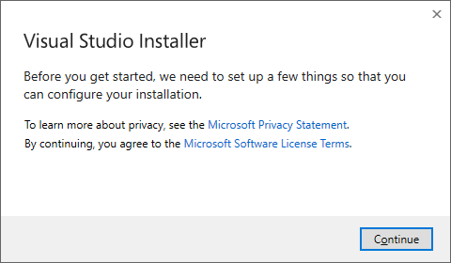

1. Click Continue to run the installer

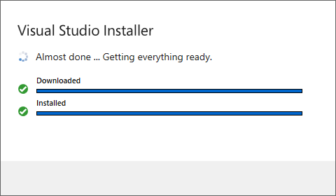

1. When the installer is running you will get this window and you must chose the components to install.

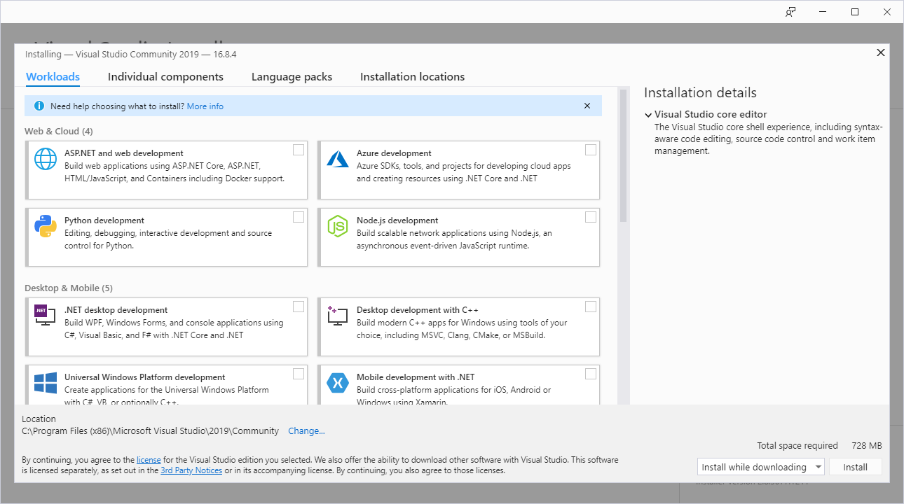

1. In the Web & Cloud Section, select ASP.NET and web development
2. In the Desktop and Mobile Section, select .NET Desktop Development and Desktop Development with C++.

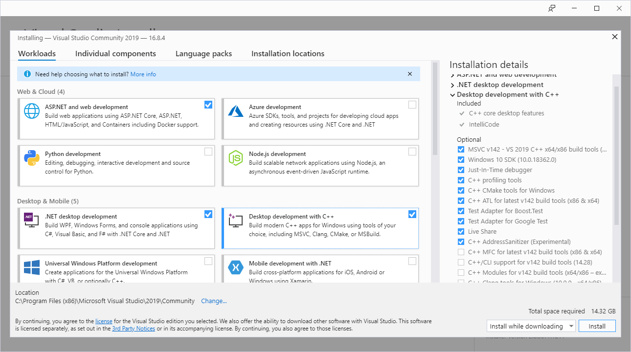

1. Click Install to begin installation.